IP CABLING TRANSMISSION – POE Switch
ITEM NO.: IP06H 5 Port High Power POE Switch

IP06H PoE switch is specifically designed to meet IEEE 802.3at standards with support up to Gigabit speed and powering network devices. With PoE installation of network devices such as IP surveillance cameras, wireless access points, IP phones, and other PoE enabled devices in hard-to-reach, outdoor, and remote areas is simplified.

Features:
- 4-Port 10/100/1000Mbps with embedded PoE Injector.
- 1-Port 10/100/1000Mbps for connecting to LAN.
- Auto-sensing for detecting PoE or non-PoE devices.
- Compatible IEEE 802.3at PoE standard.
- 2 units install at TPN002 rack mounting become 8 ports Switch.
- Internal power supply.
- Option Model: TRN002 1U 19” Rack Mounting Panel

Installation View:

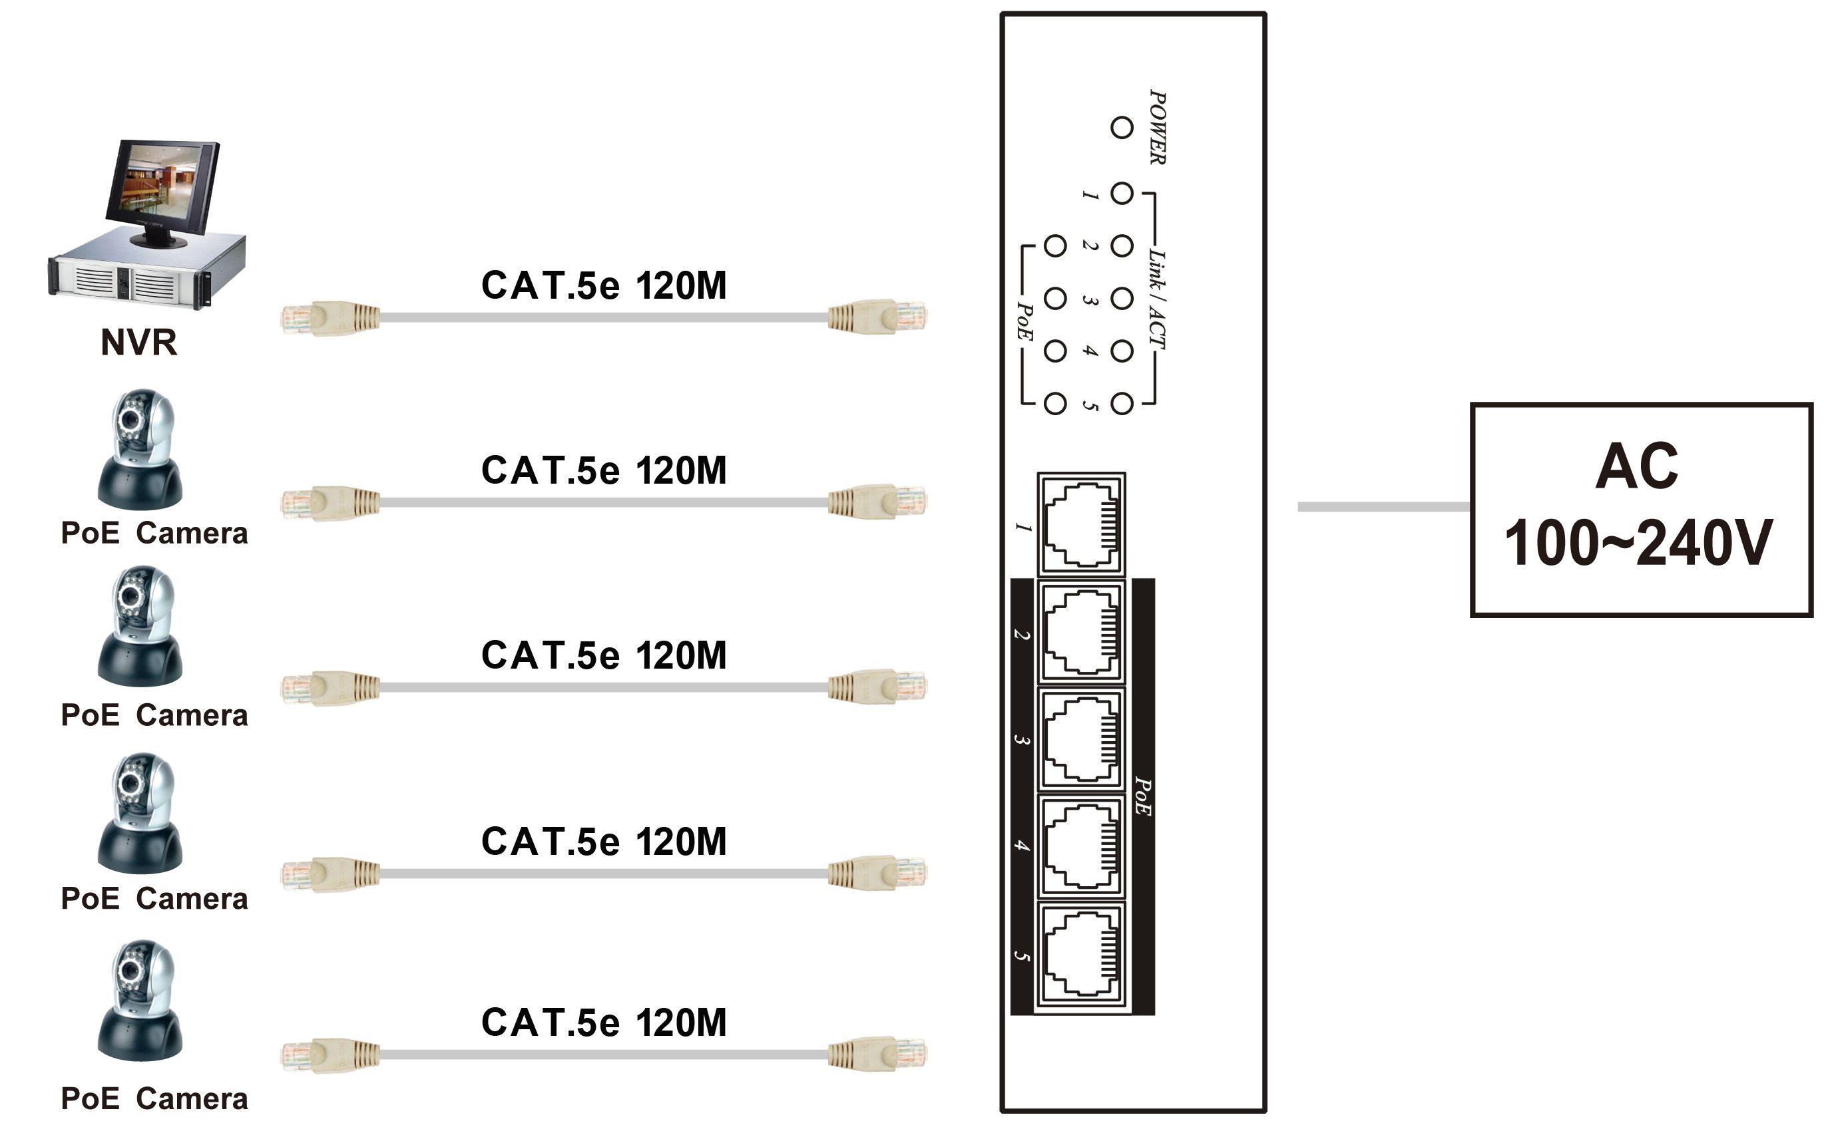

- Option Model: TRN002 1U 19” Rack Mounting Panel
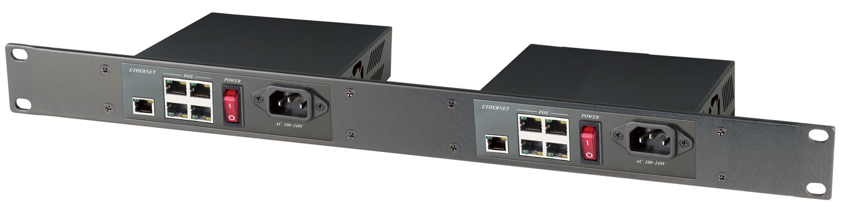

Panel View:

IP06H
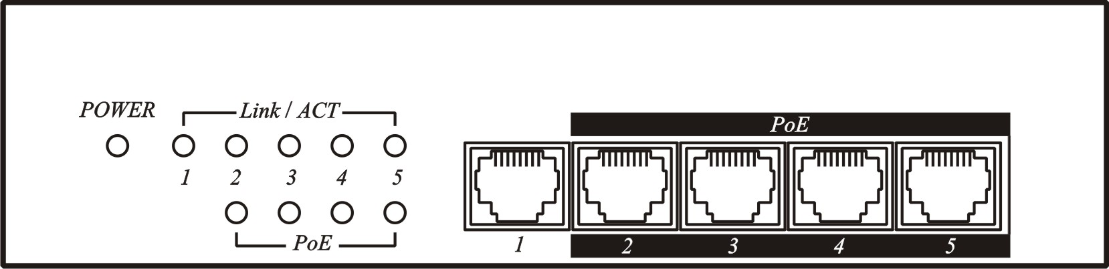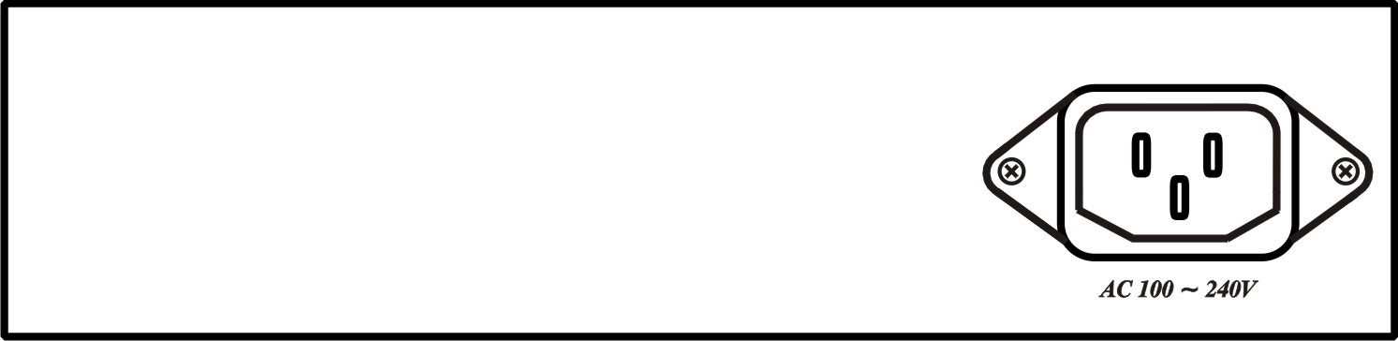

LED Indication:

LED (Green) | ON | Power on
LED (Green) | OFF | Power off
Link/ACT (Yellow) | ON | 10/100/1000 Mbps link
Link/ACT (Yellow) | OFF | 10/100/1000 Mbps unlink
Link/ACT (Yellow) | FLASH | Activity
PoE (Green) | ON | PSE sending power
PoE (Green) | OFF | PSE non power

Specification:

ITEM NO. | IP06H
Input/Output Connector | RJ-45 x 5
Data Link | Pins 1, 2 / 3, 6 / 4, 5 / 7, 8
Power LinK | Pins 1, 2 / 3, 6 (End-Span)
LED Indicator | Power(Green), 10/100/1000/Act(Yellow), PoE(Green)
PoE Port Power | IEEE 802.3at Standard (1-Port 30W/600mA)
Power Supply | DC 54V 120W 2.22A
Power Consumption | Non-load 2.6W (48mA)，4port 4.1W (76mA)@10/100Mbps，4port 6.3W (116mA)@1000Mbps
Temperature | Operation：0 to 55°C, Storage：-20 to 85°C, Humidity：Up to 95%
Dimensions | 187 x 136.6 x 42 (mm)
Weight | 860 (g)

Rev.A

FORESIGHT CCTV INC.
5863 Leslie Street, Unit#713, North York, Ontario, Canada, M2H 1J8
http://www.foresight-cctv.com | 1-888-GO2-CCTV

